Volume
# Source: AI Source: Provided by: [Data Path: Persons Table -> ID Column: 1, Name_En Column: Motasem Essam] -> From: [ChatGPT] on [7/17/2026]
Volume is the measurement of the amount of three-dimensional space occupied by an object or substance. It is a fundamental physical quantity used in mathematics, physics, chemistry, engineering, architecture, manufacturing, medicine, and everyday life.
Volume describes the capacity or space inside a solid object or container and is measured in cubic units.

Definition
# Source: AI Source: Provided by: [Data Path: Persons Table -> ID Column: 1, Name_En Column: Motasem Essam] -> From: [ChatGPT] on [7/17/2026]
Volume is the physical quantity that measures the amount of three-dimensional space occupied by a solid, liquid, or gas.
Unlike area, which measures a two-dimensional surface, volume measures three-dimensional space (length × width × height).

Purpose
# Source: AI Source: Provided by: [Data Path: Persons Table -> ID Column: 1, Name_En Column: Motasem Essam] -> From: [ChatGPT] on [7/17/2026]
Volume measurement is used to:
- Determine the size of three-dimensional objects.
- Measure liquid capacity.
- Calculate storage space.
- Estimate material quantities.
- Design containers and buildings.
- Perform scientific experiments.
- Solve geometric and engineering problems.

SI Unit
# Source: AI Source: Provided by: [Data Path: Persons Table -> ID Column: 1, Name_En Column: Motasem Essam] -> From: [ChatGPT] on [7/17/2026]
The SI derived unit of volume is:
$$1\text{ cubic meter (m³)}$$
Since volume is derived from length:
$$1 {\text{m}}^{3}=1\text{ m}×1\text{ m}×1\text{ m}$$

Common Units of Volume
# Source: AI Source: Provided by: [Data Path: Persons Table -> ID Column: 1, Name_En Column: Motasem Essam] -> From: [ChatGPT] on [7/17/2026]
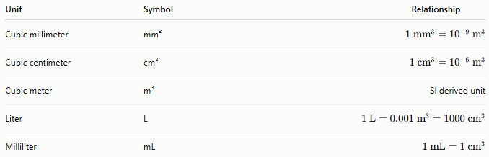
Unit | Symbol | Relationship
Cubic millimeter | mm³ | $$1 {\text{mm}}^{3}={10}^{-9} {\text{m}}^{3}$$
Cubic centimeter | cm³ | $$1 {\text{cm}}^{3}={10}^{-6} {\text{m}}^{3}$$
Cubic meter | m³ | SI derived unit
Liter | L | $$1\text{ L}=0.001 {\text{m}}^{3}=1000 {\text{cm}}^{3}$$
Milliliter | mL | $$1\text{ mL}=1 {\text{cm}}^{3}$$

Measuring Instruments
# Source: AI Source: Provided by: [Data Path: Persons Table -> ID Column: 1, Name_En Column: Motasem Essam] -> From: [ChatGPT] on [7/17/2026]
Volume can be measured using:
For Solid Objects
- Ruler
- Measuring tape
- Vernier caliper
- Micrometer (small objects)
For Liquids
- Graduated cylinder
- Measuring cup
- Beaker
- Pipette
- Burette
- Volumetric flask

Volume Formulas

Cube
# Source: AI Source: Provided by: [Data Path: Persons Table -> ID Column: 1, Name_En Column: Motasem Essam] -> From: [ChatGPT] on [7/17/2026]
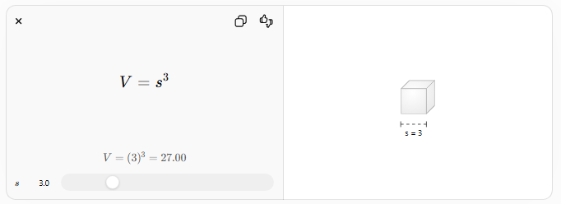
$$V=s^{3}$$
where:
- $V$= volume
- $s$= side length

Rectangular Prism (Cuboid)
# Source: AI Source: Provided by: [Data Path: Persons Table -> ID Column: 1, Name_En Column: Motasem Essam] -> From: [ChatGPT] on [7/17/2026]
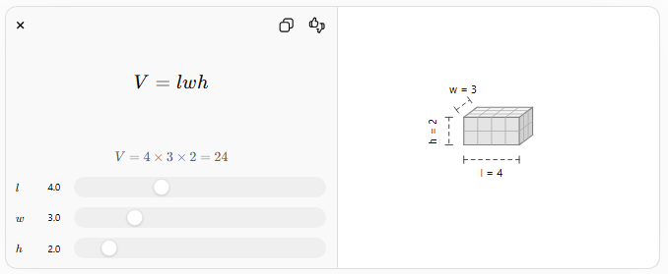
$$V=lwh$$
where:
- $l$= length
- $w$= width
- $h$= height

Cylinder
# Source: AI Source: Provided by: [Data Path: Persons Table -> ID Column: 1, Name_En Column: Motasem Essam] -> From: [ChatGPT] on [7/17/2026]
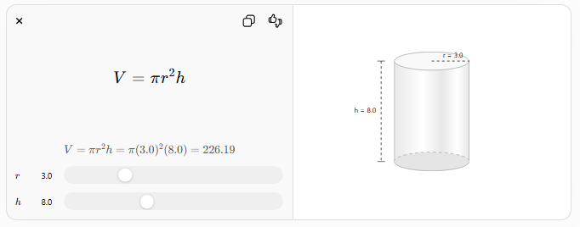
$$V=πr^{2}h$$
where:
- $r$= radius
- $h$= height

Cone
# Source: AI Source: Provided by: [Data Path: Persons Table -> ID Column: 1, Name_En Column: Motasem Essam] -> From: [ChatGPT] on [7/17/2026]
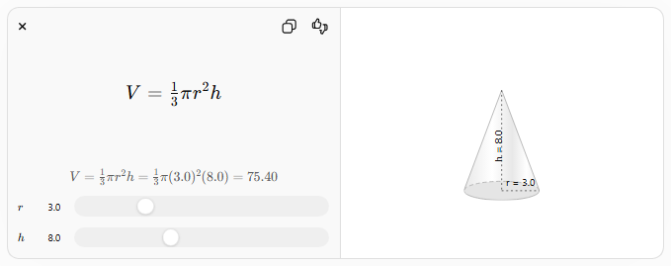
$$V=\frac{1}{3}πr^{2}h$$
where:
- $r$= radius
- $h$= height

Sphere
# Source: AI Source: Provided by: [Data Path: Persons Table -> ID Column: 1, Name_En Column: Motasem Essam] -> From: [ChatGPT] on [7/17/2026]
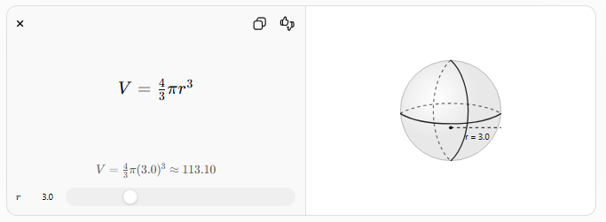
$$V=\frac{4}{3}πr^{3}$$
where:
- $r$= radius

Measurement Process
# Source: AI Source: Provided by: [Data Path: Persons Table -> ID Column: 1, Name_En Column: Motasem Essam] -> From: [ChatGPT] on [7/17/2026]
To determine volume:
- Measure the necessary dimensions.
- Select the appropriate geometric formula.
- Substitute the measured values.
- Calculate the result.
- Express the answer using cubic units or liters, as appropriate.

Examples
# Source: AI Source: Provided by: [Data Path: Persons Table -> ID Column: 1, Name_En Column: Motasem Essam] -> From: [ChatGPT] on [7/17/2026]
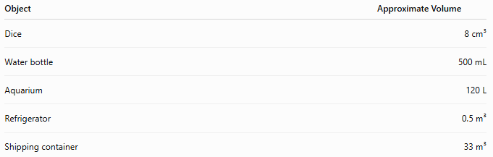
Object | Approximate Volume
Dice | 8 cm³
Water bottle | 500 mL
Aquarium | 120 L
Refrigerator | 0.5 m³
Shipping container | 33 m³

Unit Conversions
# Source: AI Source: Provided by: [Data Path: Persons Table -> ID Column: 1, Name_En Column: Motasem Essam] -> From: [ChatGPT] on [7/17/2026]
Common conversions:
- 1 m³ = 1,000,000 cm³
- 1 L = 1000 mL
- 1 L = 1000 cm³
- 1 mL = 1 cm³
- 1 m³ = 1000 L
Examples:
- 2 L = 2000 mL
- 5 m³ = 5000 L
- 250 mL = 250 cm³

Accuracy
# Source: AI Source: Provided by: [Data Path: Persons Table -> ID Column: 1, Name_En Column: Motasem Essam] -> From: [ChatGPT] on [7/17/2026]
Accurate volume measurement depends on:
- Accurate dimension measurements.
- Correct formula selection.
- Proper unit conversion.
- Appropriate measuring instruments.
- Correct reading of liquid levels (meniscus).

Applications
# Source: AI Source: Provided by: [Data Path: Persons Table -> ID Column: 1, Name_En Column: Motasem Essam] -> From: [ChatGPT] on [7/17/2026]
Volume measurement is essential in:
- Geometry
- Physics
- Chemistry
- Engineering
- Architecture
- Manufacturing
- Medicine
- Pharmacy
- Food production
- Environmental science

Everyday Importance
# Source: AI Source: Provided by: [Data Path: Persons Table -> ID Column: 1, Name_En Column: Motasem Essam] -> From: [ChatGPT] on [7/17/2026]
Volume measurement is used for:
- Measuring beverages.
- Cooking ingredients.
- Fuel storage.
- Water tanks.
- Shipping packages.
- Building construction.
- Medicine dosage.
- Laboratory experiments.

Common Mistakes
# Source: AI Source: Provided by: [Data Path: Persons Table -> ID Column: 1, Name_En Column: Motasem Essam] -> From: [ChatGPT] on [7/17/2026]
- Confusing volume with capacity.
- Forgetting to use cubic units.
- Using the wrong geometric formula.
- Incorrect unit conversions.
- Reading liquid levels incorrectly.

Key Points
# Source: AI Source: Provided by: [Data Path: Persons Table -> ID Column: 1, Name_En Column: Motasem Essam] -> From: [ChatGPT] on [7/17/2026]
- Volume measures the amount of three-dimensional space occupied by an object or substance.
- The SI derived unit is the cubic meter (m³).
- Liquids are commonly measured in liters (L) and milliliters (mL).
- Different solids require different geometric formulas.
- Accurate volume measurement depends on precise dimension measurements and correct techniques.

Volume vs. Capacity
# Source: AI Source: Provided by: [Data Path: Persons Table -> ID Column: 1, Name_En Column: Motasem Essam] -> From: [ChatGPT] on [7/17/2026]
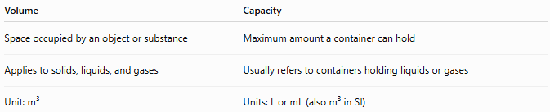
Volume | Capacity
Space occupied by an object or substance | Maximum amount a container can hold
Applies to solids, liquids, and gases | Usually refers to containers holding liquids or gases
Unit: m³ | Units: L or mL (also m³ in SI)

Volume vs. Area
# Source: AI Source: Provided by: [Data Path: Persons Table -> ID Column: 1, Name_En Column: Motasem Essam] -> From: [ChatGPT] on [7/17/2026]
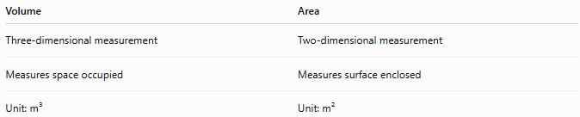
Volume | Area
Three-dimensional measurement | Two-dimensional measurement
Measures space occupied | Measures surface enclosed
Unit: m³ | Unit: m²

Volume vs. Mass
# Source: AI Source: Provided by: [Data Path: Persons Table -> ID Column: 1, Name_En Column: Motasem Essam] -> From: [ChatGPT] on [7/17/2026]
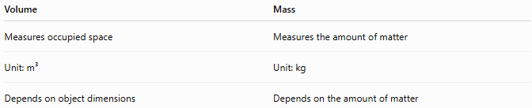
Volume | Mass
Measures occupied space | Measures the amount of matter
Unit: m³ | Unit: kg
Depends on object dimensions | Depends on the amount of matter

Conclusion
# Source: AI Source: Provided by: [Data Path: Persons Table -> ID Column: 1, Name_En Column: Motasem Essam] -> From: [ChatGPT] on [7/17/2026]
Volume is the measurement of the amount of three-dimensional space occupied by an object or substance. It is a derived quantity in the International System of Units, with the cubic meter (m³) as its standard unit. For liquids, the liter (L) and milliliter (mL) are widely used practical units. Volume is determined by measuring dimensions and applying the appropriate geometric formula or by using calibrated volumetric instruments. It is fundamental in science, engineering, manufacturing, medicine, construction, and everyday activities involving solids, liquids, and gases.

